HTML Forms Chapter 4- Students Handout
About Workshop
HTML forms are a fundamental part of web development. They allow users to input data, which can then be sent to a web server for processing. Forms are used for various purposes, such as user registration, login, search, and data collection. In this handout, you will learn how to create HTML forms and understand the key elements involved.
Workshop 1:
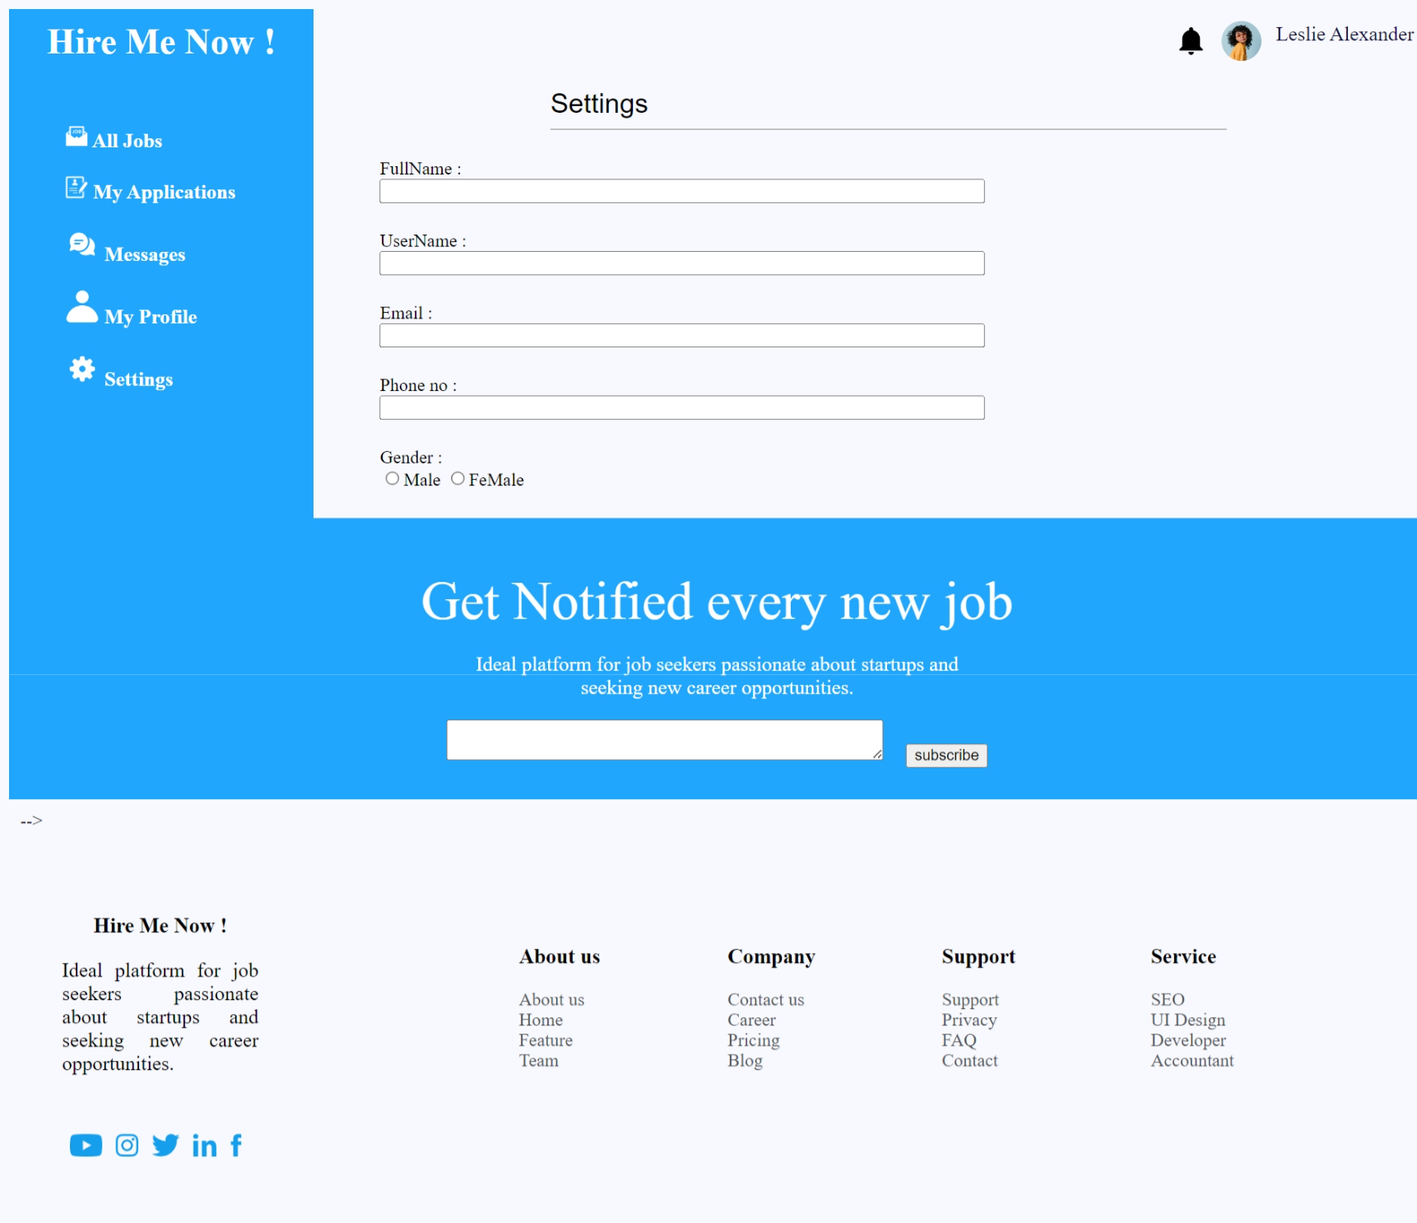

Expected Output:
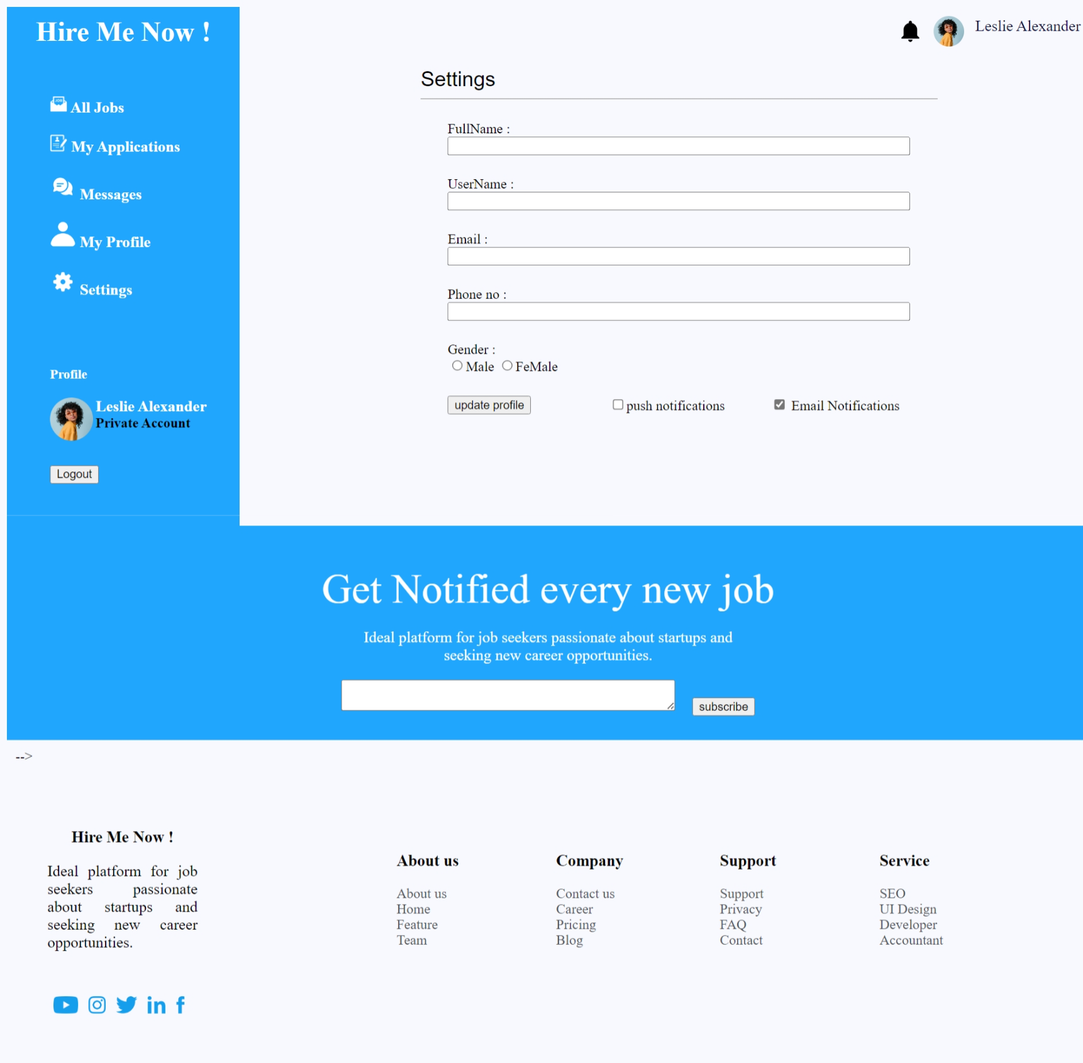
The main content area There’s a form for updating user settings. It includes fields for Full Name, Username (read-only), Email, Phone Number, and Gender (with radio buttons). There are also options for updating the profile, enabling push notifications, and email notifications. Below the settings form, there's a profile section with Leslie Alexander's name, profile image, and account status. There’s a "Logout" button below this section.
After the profile section, there's a section for users to subscribe to notifications about new jobs. It includes an input field for email and a "Subscribe" button.
The final section contains a footer with various columns for navigation links. Here is a simple explanation for the first workshop.

Workshop 2
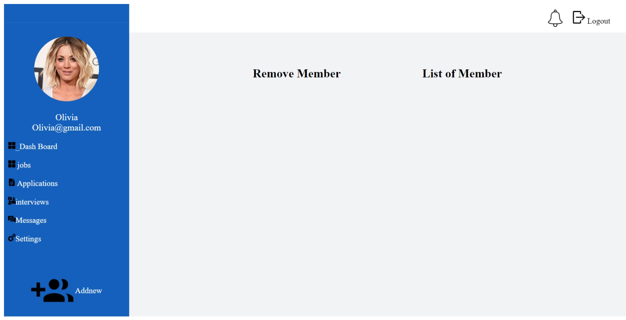
Expected Output:
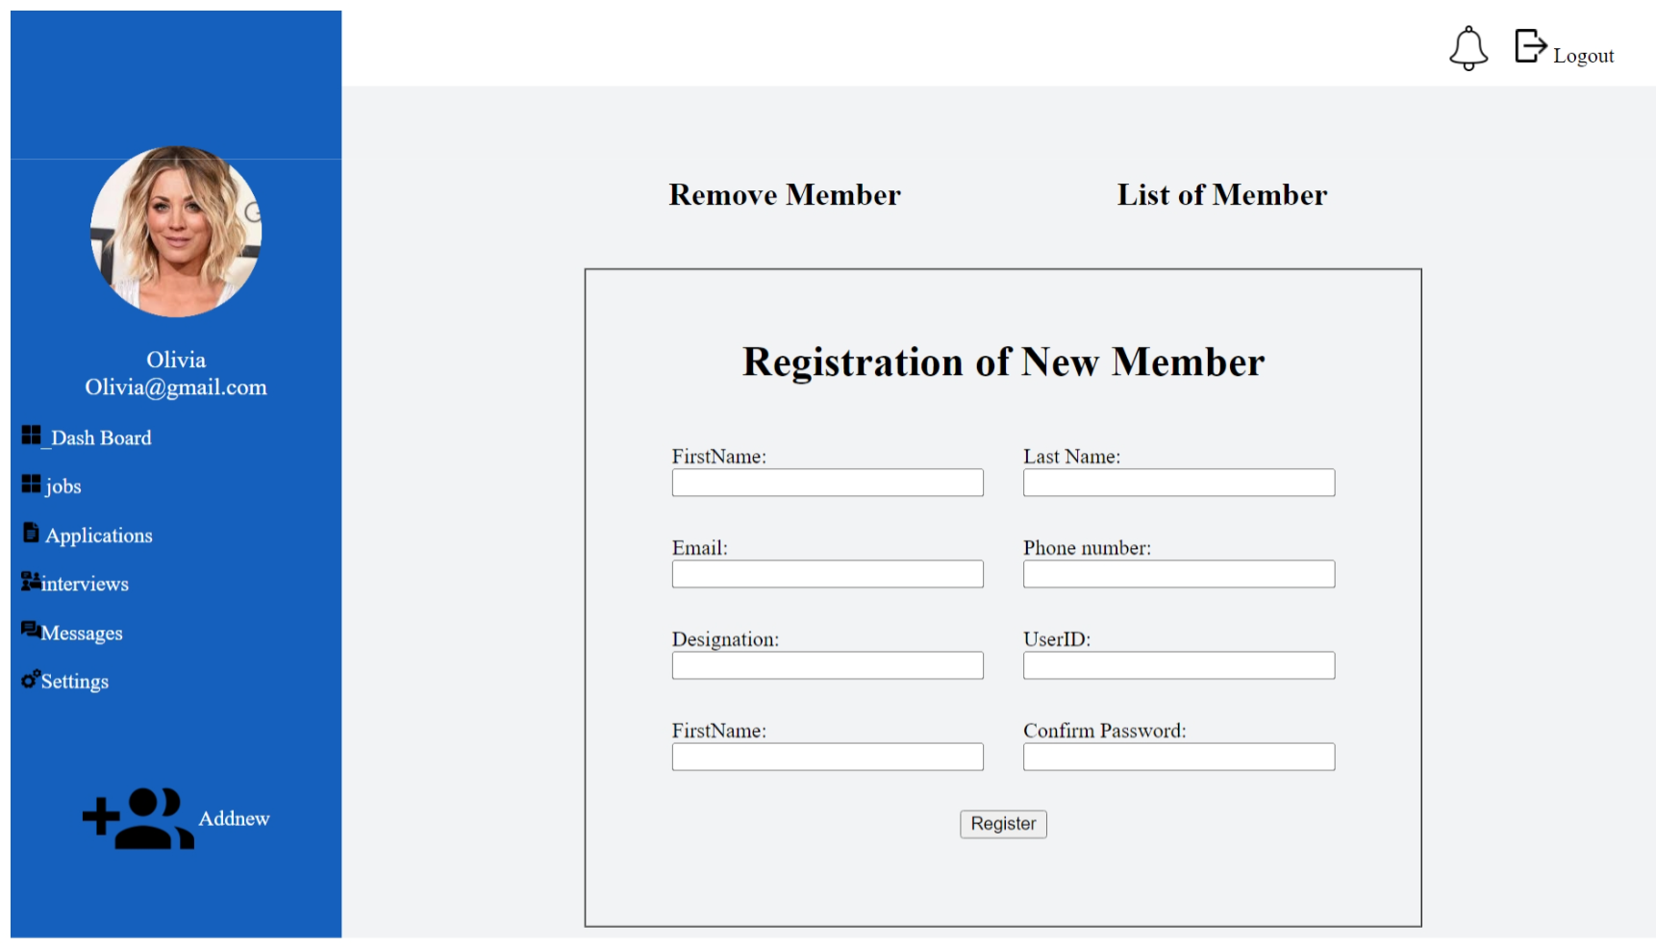

This HTML code represents a web page for a "jobseeker settings" application. It includes a navigation bar with various links, a profile section, and a registration form for adding new members. The page uses tables for layout, includes images, and form elements like text inputs and buttons to create a user interface. Students learning web development can study this code to understand how to structure a simple webpage, use HTML tags, create tables, and incorporate images and forms into their designs.
Workshop-3
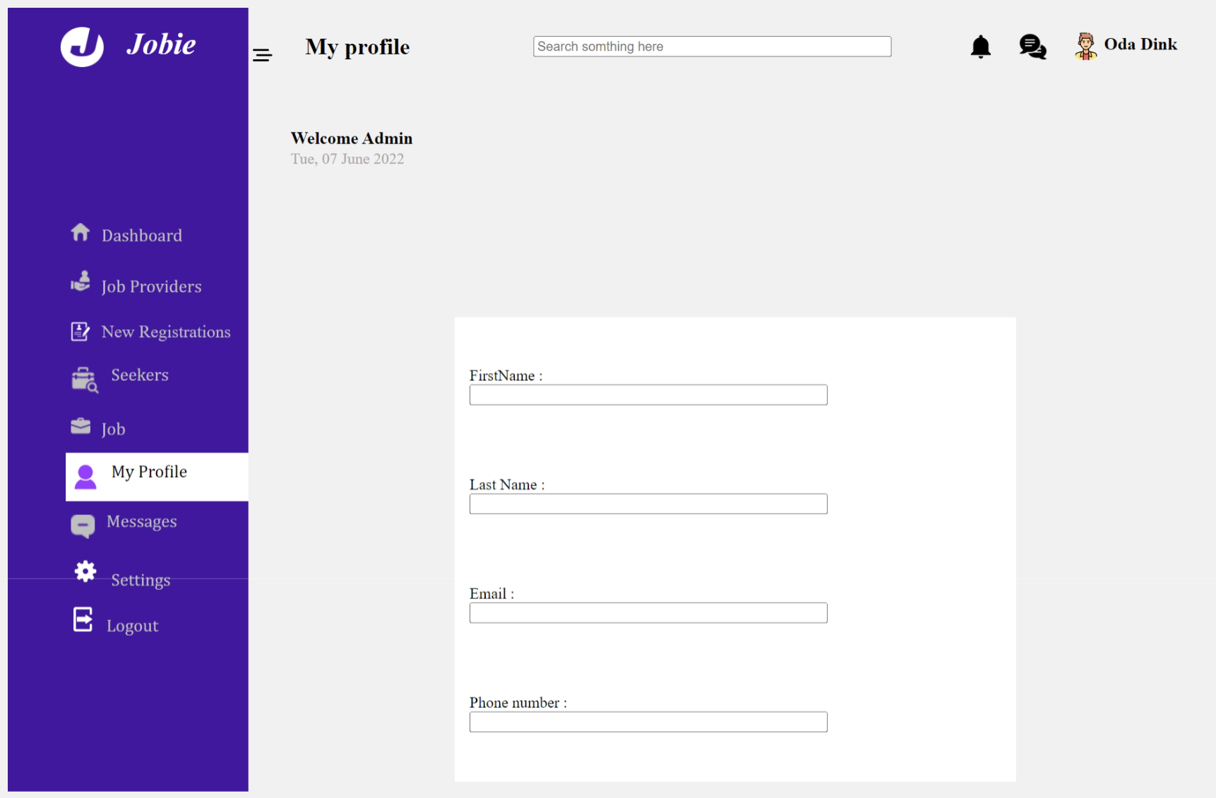
Expected Output:
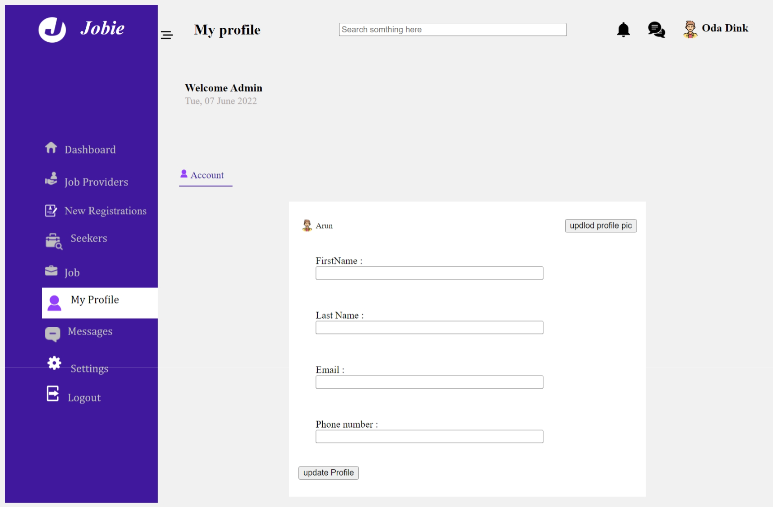
This HTML code represents a webpage for a "Jobie" application. It includes a header section with a logo, search bar, and user profile information. The page has a navigation menu with links to different sections such as Dashboard, Job Providers, Seekers, Job listings, My Profile, Messages, Settings, and Logout. The main content area contains a form for updating user profile information, including fields for First Name, Last Name, Email, and Phone number. Students learning web development can study this code to understand how to structure a webpage, create links, use images, and design a basic user interface with HTML and CSS.
Workshop-4
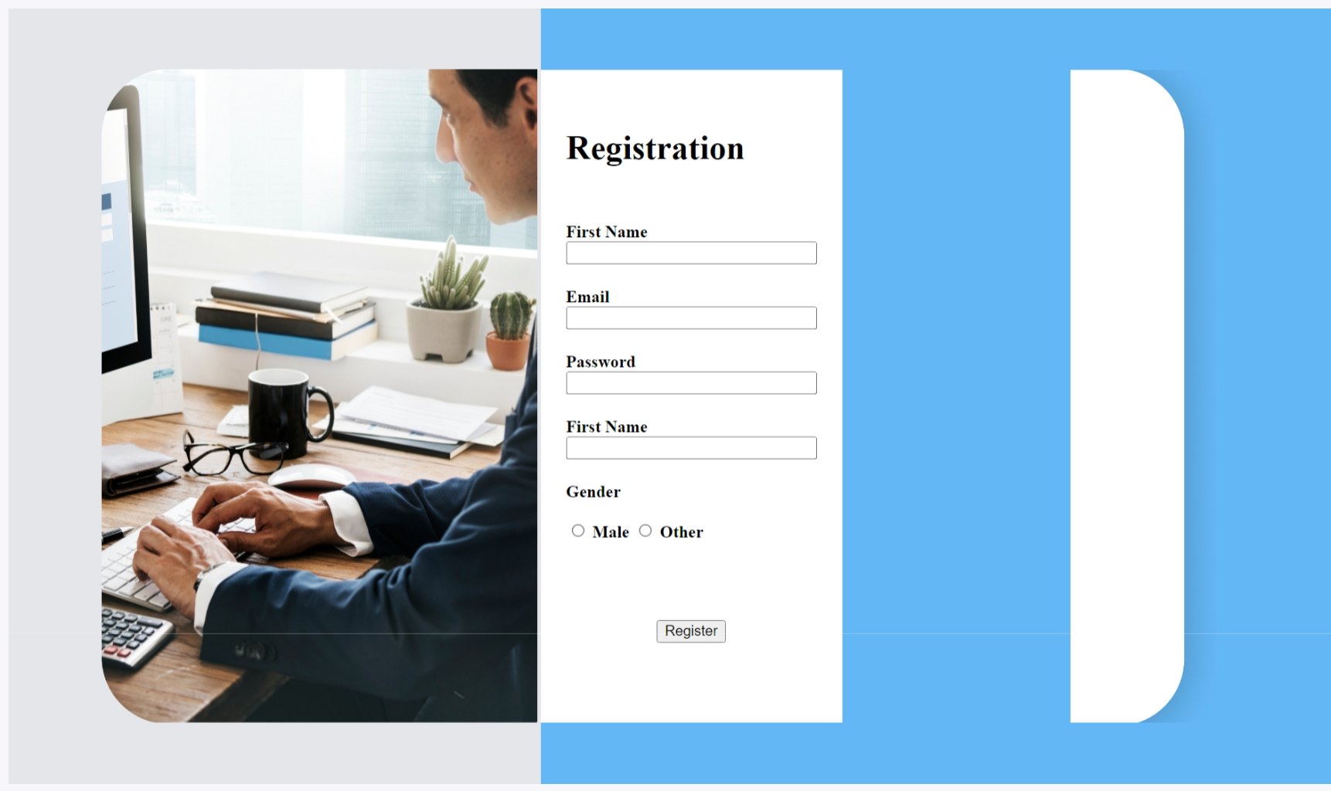
Expected Output:
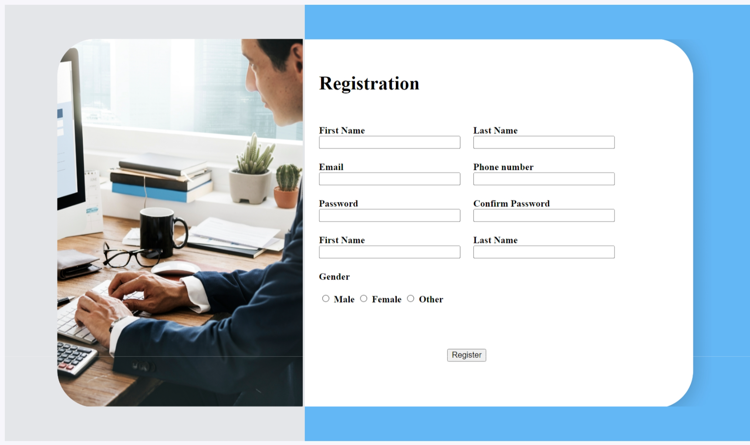
This HTML code represents a workshop registration webpage for students. It includes a title, author information, and uses a custom favicon. The page has a two-column layout with a registration form on the right side and an image on the left. The form collects information such as first name, last name, email, phone number, password, confirm password, gender, and has a registration button. The page uses various background colours and images to enhance its visual appeal.
Workshop-5
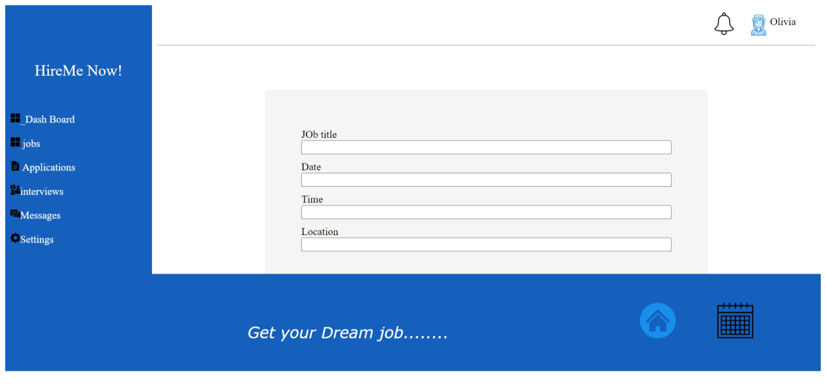
Expected Output:
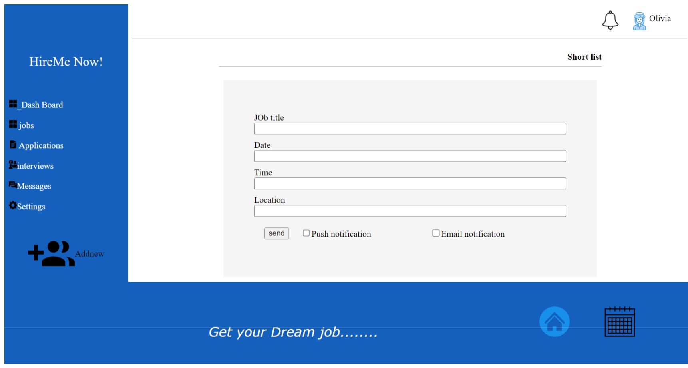
This HTML code represents a job posting webpage, potentially part of a workshop for students. It includes a header with a logo and user information, a navigation menu, and a form for posting job listings. The navigation menu on the left provides links to different sections of the website. The main content area contains a form with fields for job title, date, time, location, and notification preferences. The page also has a footer with a motivational message and icons.
Conclusion
HTML forms are essential for creating interactive and data-driven web applications. Understanding the structure and various form controls is a crucial step in web development. Experiment with different form elements and attributes to create user-friendly and functional forms for your web projects.

Feel free to customize this handout to meet your specific teaching needs or add more examples and exercises to help your students practice creating HTML forms.

